**Review Guide: Introduction to HTML and CSS**

Let’s review some of the key ideas introduced in this unit. You can also download all this content for future reference by clicking on the attached file.

**Key Definitions**

* **World Wide Web:** An information ­sharing model built on top of a global system of **inter**connected computer **net**works called the Internet.
* **Websites:** Collections of files, accessible through the world wide web.
* **Clients:** Personal devices such as computers, phones, or tablets, used to access the web.
* **Servers:** Special computers that host massive amounts of the files that make up websites. They “serve” those files to end users.
* **HTML Elements:** The building blocks of HTML. Consists of a start tag, content, and end tag.
* **HTML Tags**: HTML syntax used to indicate to a web browser how to present content. Bookended by angle brackets.

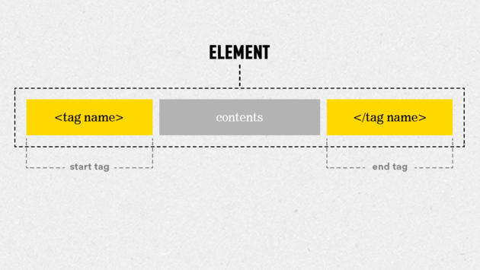

* **HTML Attribute:** Adds information to an HTML element. An HTML tag can have one or many attributes. Attributes are always included in the opening tag. They are preceded by a space, include the name of the attribute, an equal sign, and a value in quotes.

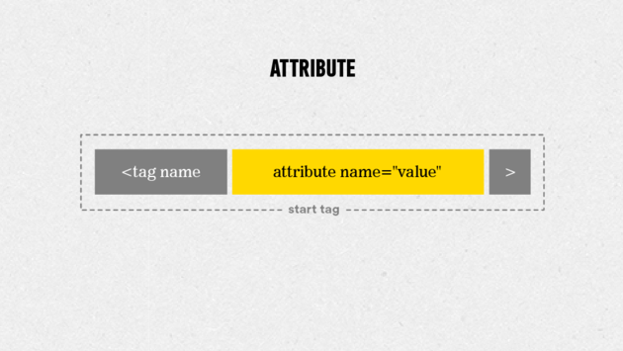

* **CSS Rule:** The building block of a CSS stylesheet. A rule consists of a selector and a declaration block (one or more declarations).
* **CSS Declaration:** A declaration is made up of a property name and a value, separated by a colon.
* **CSS Selector:** The actual HTML object the declaration(s) apply to.
* **CSS Property:** The characteristic of the selector that will be changed.
* **CSS Value:** The amount to change corresponding property of the matched selector.

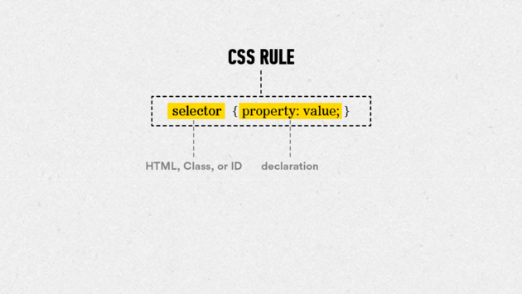

HTML vs. CSS

So what’s the difference between HTML and CSS? And when do I use each?

**HTML**, or **H**yper **T**ext **M**arkup **L**anguage, is the standard language used to code web pages. All of the content on a website is added with HTML.

**CSS** or **C**ascading **S**tyle **S**heets, decides how the content written in an HTML document looks, such as the layout, colors, and fonts.

**Common HTML Elements**

**Headline Elements:** are meant to be used for important text that titles the content that comes after it. They range from —the largest—to —the smallest.

<h1>This would make a big headline</h1>

**Paragraph Elements:** are one of the most basic tags in HTML. They indicate blocks of text.

<p>This would add a block of text to a page</p>

**Anchor Elements:** are the tags we use to create links. In order to make a working link, we have to add more information to the anchor tag, using an href attribute.

<a href="www.generalassemb.ly>This would make this whole

sentence a link to General Assembly's home page.</a>

**HTML Boilerplate**

In order to organize tags properly, start with a set of structural elements called the HTML boilerplate. It should look like this:

***<!DOCTYPE html>***

<html>

<head>

</head>

<body>

</body>

</html>

**Common CSS Properties and Values**

**Property #1:**  
**color —** This CSS property allows you to adjust the *text* color of the selected element.

For example, to turn the text of an element green, you would create the following CSS rule:

h1 {

**color:** #00ff00;

}

**Property #2:**  
**background-color —** This CSS property allows you to adjust the *background* color of the selected element.

For example, to turn the background of a web page yellow, you would enter the following CSS rule:

body {

background**-color:** #ffff00;

}

**Common Values:**  
There are 17 standard color values that you can pair with the color and background-color properties — aqua, black, blue, fuchsia, gray, green, lime, maroon, navy, olive, orange, purple, red, silver, teal, white, and yellow.

Additionally, there are 123 more colors that are generally accepted as standard. You can find the entire list [here](http://www.w3schools.com/cssref/css_colornames.asp).

You can also create custom colors using RGB and hexadecimal codes, which we'll discuss in Unit 3.

**Questions to Ask Your Mentor**

1. How did you first get introduced to HTML and CSS?
2. Can you show me some examples of websites with basic HTML and CSS code?
3. What are your favorite web designers and websites?
4. Before you sit down to create a website, what steps do you take to prepare?
5. What are some good resources that you typically use for learning about web design?

**Resources**

* [Sublime Text](http://www.sublimetext.com/3) — A free text editor used for building HTML and CSS files. It's available for both Mac OS X and Windows.
* [Google Chrome](https://www.google.com/chrome/browser/desktop/index.html) — The primary web browser used to demonstrate rendered code throughout this course. It's available for both Mac OS X and Windows.
* [wireframe.cc](https://www.wireframe.cc/) — A free tool for creating web design mockups. It operates in your web browser, so you don't even need to download it. You'll learn how to create design mockups with wireframe.cc in our next unit.

**Further Reading**

Looking for more help with the Basics of HTML? Here are a couple places you can check out:

More basics on HTML and CSS (read up until the section called "In Practice"):  
<http://learn.shayhowe.com/html-css/terminology-syntax-intro>

More info on getting started:  
[http://www.htmldog.com/guides/html/beginner/gettingstarted](http://www.htmldog.com/guides/html/beginner/gettingstarted/)

Intro to HTML tags:  
<http://www.htmldog.com/guides/html/beginner/tags/>

Intro to title elements:  
<http://www.htmldog.com/guides/html/beginner/titles/>

Intro to paragraph elements:  
<http://www.htmldog.com/guides/html/beginner/paragraphs/>

Intro to heading elements:  
<http://www.htmldog.com/guides/html/beginner/headings/>

The first web page ever posted on the Web:  
<http://info.cern.ch/hypertext/WWW/TheProject.html>

Also, please feel free to reach out to your mentor to discuss any of the topics in this unit further.

[←](https://circuits.generalassemb.ly/student/209/pages/785?direction=back) [→](https://circuits.generalassemb.ly/student/209/quizzes/232)

**Downloads**

[Summary](https://ga-sprites.s3.amazonaws.com/uploads/production/page/downloadable_content/137/Summary.zip)

© 2016 General Assembly. All rights reserved. [Regulatory Information](https://generalassemb.ly/regulatory-information) [Terms](https://generalassemb.ly/terms_and_conditions) [Privacy](https://generalassemb.ly/privacy_policy) [Assembled](http://nytm.org/made-in-nyc)

# Project: Part 1 — Creating Your First Web Page

Welcome to your first Circuits project!

Throughout the course, we’ll guide you through the creation of your very own website. The content of your website will revolve around a business. It can be a real business that you own or work at, a fictional business that you'd like to create, or a personal brand page.

If you’re interested in seeing some previous students' final projects to get some inspiration, you can do so [here](https://gallery.generalassemb.ly/WDC?metro=).

In this week's project, you'll create a basic web page and host it online. The following steps will help guide you:

## Step 1

Create a new folder on your computer.

To create a new folder, go to the location where you want to create a new folder (such as your documents folder or the desktop) and right-click any blank area (or press CTRL + click). This will create a pop-up menu from which you can select **new folder**.

Name your new folder **unit_1**.

## Step 2

Open Sublime Text and create a new file. Name the file **index.html** and save it in the **unit_1** folder you created in Step 1. This will tell Sublime Text that the file you're working on is an HTML file.

## Step 3

Incorporate the HTML boilerplate elements into your index.html file:

<!DOCTYPE html>

<html>

<head>

<title>

<body>

The title for this webpage should be: “[the name of your business]”

## Step 4

Populate the body element with the <h1> text: “[the name of your business]” and the paragraph text: “This is the [business type] of [your name here]”

For example:

<body>

<h1>Batcave</h1>

<p>This is the secret headquarters of Batman</p>

</body>

You probably have a lot more to say than that, but don't worry! You'll have plenty of time to upgrade the text on your site later. Our main focus for now is getting your page up and running.

## Step 5

Within your **unit_1** folder, create a subfolder called **css**.

Back in Sublime Text, create a new file, name it **style.css**, and save it in your new **css** folder. This will be your external style sheet.

In this file, set the text color to any color besides black, and the background color to any color besides white.

For example:

body {

background-color: black;

}

h1, p {

color: gold;

}

When you're done, make sure to link to your new style sheet to your web page inside the <head> section of your HTML file using the following element:

<link rel="stylesheet" type="text/css" href="css/style.css">

Don't forget to save **both** your HTML and CSS files once you've reached this point.

## Step 6

Congrats! You've created the files necessary to create a basic web page. Next, you're going to take these files and host them online using a service called GitHub.

To learn how, please continue to the next activity, which is a step-by-step slideshow to help you through this process.

[←](https://circuits.generalassemb.ly/student/209/quizzes/232?direction=back) [→](https://circuits.generalassemb.ly/student/209/slideshows/198)

© 2016 General Assembly. All rights reserved